SARNIA BLUEWATER WRESTLING CLUB
YOUTH WRESTLING 2025 Season
For Boys and Girls
Wrestling. The World’s oldest Sport.
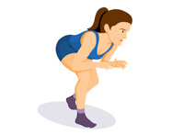
Training Times: Sessions Start Tuesday January 13, 2026
Grades 1-6 Tuesday and Thursdays 6:30 to 7:30
Grades 7-8 Tuesday and Thursday 7:30 to 9:00
Location: St Patrick’s Catholic HS in the Cafeteria
Cost: $ 220 For 17 week program.
Includes membership to Sarnia Wrestling Club and the Ontario Amateur Wrestling Association
Our coaches are certified through the Coaches Association of Canada and Sport Canada
For more information:
John Burke Coach: john.burke966@gmail.net 519 466-7403
Jeff VanderSlagt Youth Head Coach: Sarnia Wrestling youshouldwrestle@gmail.com
See us on Facebook: Sarnia Bluewater Wrestling Club www.sarniawrestling.ca


