SARNIA BLUEWATER WRESTLING CLUB
YOUTH WRESTLING 2023 Season
For Boys and Girls
Wrestling. The World’s oldest Sport.
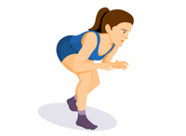
Training Times: Sessions Start January 19, 2023
Grades 1-6 Tuesday and Thursdays 6:30 to 7:30
Grades 7-8 Tuesday and Thursday 7:30 to 9:00
Location: St Patrick’s Catholic HS in the Cafeteria
Cost: $ 150 Includes membership to Sarnia Wrestling Club and the Ontario Amateur Wrestling Association, T-Shirt and Awards
Our coaches are certified through the Coaches Association of Canada and Sport Canada
For more information:
John Burke Coach: St Patrick’s HS and Sarnia Wrestling Club
john.burke966@gmail.net 519 466-7403
Jeff VanderSlagt Youth Head Coach: Sarnia Wrestling youshouldwrestle@gmail.com
See us on Facebook: Sarnia Bluewater Wrestling Club
www.sarniawrestling.ca 