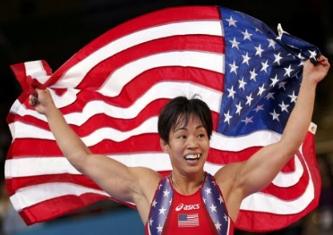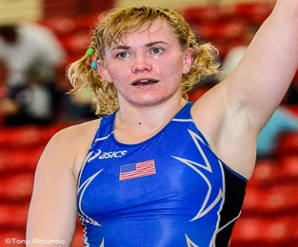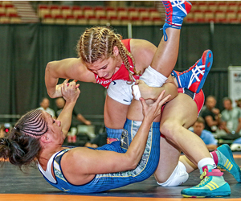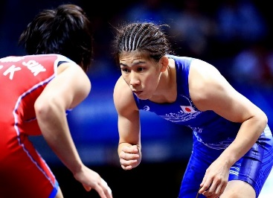
Saturday April 1, 2017
7th ANNUAL GIRLS
NEW ENGLAND FREESTYLE
WRESTLING CHAMPIONSHIP
We had over 130 girls last year!

“THE REVOLUTION IN SPRINGFIELD”
Tournament information:

Date: Saturday April 1, 2017
Location: Springfield Technical Community College
One Armory Square
Springfield, Ma 01102 (Building #2/ GYM)
Cost: $30 per tournament (no cost for wrestling in 2 divisions)
Awards: Medals to top 3, Certificates top 6
Team awards to 1st place HS/Club team only
Start time: 10am
Pre-Registration: Read information below please

IMPORTANT! MUST READ for REGISTRATION: Pre-registrar name & weigh-ins:
All Weigh-ins will be done at your club or at home with a coach or parent. THIS IS A HONOR WEIGH-IN. Coach or Parent must email your name, weight & school/club & division only on Friday March 31, 2017 between 9am and 6pm (send email to nieveswrestling@gmail.com) or text only 413-221-5633.

Division & Weight Classes:
K-2 grade, 3-4 grade, 5-6 grade, 7-8 grade: Madison wt. classes (with in 5lbs)

9-12 Grade: 97, 105, 112, 117, 121, 125, 130, 139, 148, 159, 175, 198 plus
Open Division: 106, 117, 121, 130, 139, 148, 159, 165, 175, 176 plus

Contact info Coach Anibal Nieves 413-221-5633 / nieveswrestling@gmail.com

