Sarnia Bluewater Wrestling Club
Custom Singlet Order Form

Name: _______________________________ Female Male
Contact information_________________________________________________
Do You Want You Name of the Back? YES NO
Yes: Please print in block letters what you want:
____________________________________________________________________________________
Sarnia Bluewater Wrestling Club Custom Singlets in Blue and Red for Women and Men
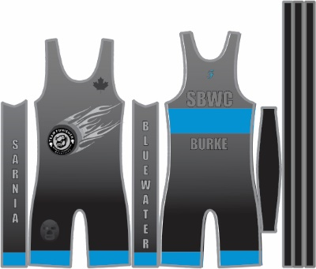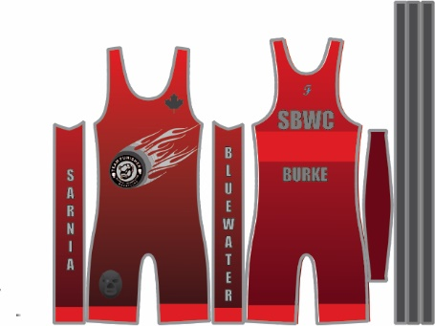

Colours: Please circle Blue Quantity ___ Size ____ Red Quantity ___ Size ____

COST is $70 / singlet Taxes and delivery are included
Payment: Type ____________________________________________ Total ________________
Due Date: ______________________Received: ___________________________________________
Delivered: ______________________________________________
Payment: Cash, cheque (Sarnia Bluewater Wrestling Club or e transfer)
Please contact john.burke966@gmail.com or 519 466-7403

See Our Sizing Chart From Takedown Distribution

