The Sarnia Bluewater Wrestling Club and the LKSSAA Wrestling Coaches Association present:
Wrestling Clinic
Featuring:
ROY HALL
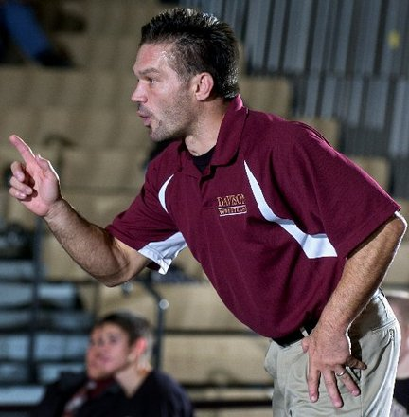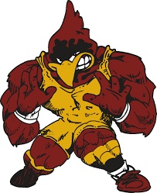

- Member of the USA Wrestling Hall of Fame
- Coach Hall has led Davison HS to six state championships and five second-place finishes during 22 seasons as head coach
- NCAA All- American Michigan State and Purdue University
- Michigan Wrestling Coach of the Year
- Coach of many NCAA Champions at schools like Iowa, Iowa State, Nebraska
Date: Sunday November 4th, 2018 2 sessions: 10:30-12:30 and 1:30 – 3:30
Location: Great Lakes HS Sarnia, ON in the wrestling room (room 99)
Cost: $10 for non-members of the Sarnia Bluewater Wrestling Club and $5 for members
Please contact John Burke 519 466-7403 john.burke966@gmail.com
www.sarniawrestling.ca on Facebook Sarnia Bluewater Wrestling Club

