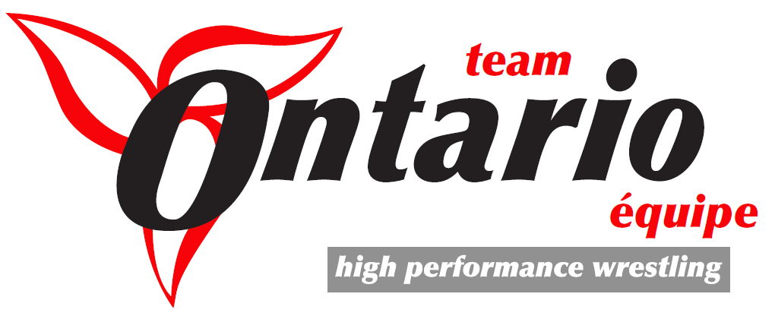
2017 OHP Wrestling Combine

On behalf of the Ontario Amateur Wrestling Association and the Ontario High Performance Team, we would like to take this opportunity to invite you to participate in an athlete combine Saturday October 21, 2017. We have invited representatives from Ontario University wrestling programs to run the sessions which will give them to opportunity to scout.

This invitation has been sent to last year’s Provincial and National medalists.

Cost: $25.00 per athlete (includes a souvenir T-shirt). Please bring or arrange for your own lunch. No accommodations provided.
Registration fee after October 13, $35 and we can’t guarantee a t-shirt with late registration.

Date: Saturday October 21, 2017 8:30am-5pm

Location: Bishop Ryan High School 1824 Rymal Road East, Hannon, ON (Hamilton Escarpment)

Email your intentions to participate to ohpwrestling@gmail.com by Friday October 13, 2017. You will receive a registration link upon receipt of your email.

Participation in the combine will be capped at 40 athletes – first come, first served.

Email: OHPwrestling@gmail.com

Contact: Chris Stefopulos (416) 859 -6985

Hoping to get on the radar for a university wrestling team? Hoping to be invited to participate in the 2017 – 2018 OHP? Plan to attend the Combine!

Here is the registration link: https://docs.google.com/forms/d/1pu2_yTfXeJ_gnf8pgaMWcgF1lgxnllgXF_fxxIu1zvI/viewform?edit_requested=true

